Crypts & Daggers

Gavin McGuire

Michael Sweeny

Table of Contents

1. Overview
   1. Target Audience
   2. Genre
   3. Visual Style
   4. Platform
   5. Player End-Goals
2. Gameplay
   1. Difficulty
   2. Game Mechanics
3. Game Flow and Progression
   1. Level Design
4. Story
5. Technical
6. Timeline
   1. Design/Planning
   2. Pre-Production
   3. Production
   4. Post-Production
7. Overview

Crypts & Daggers (C&D) is a Top-Down orthographic dungeon crawler for iOS mobile devices. Targeted at young teens, the format for the game will be fairly simple. The player is an adventurer who has found himself in a mystical crypt and he must find his way to the next level and eventually make his way out.

1.1 Target Audience

* The anticipated player base for C&D is youth from ages 9-17
* iOS mobile devices are fairly commonly used

1.2 Genre

C&D is a dungeon crawler. Players’ logical reasoning skills are challenged at a progressively more intense rate with each level. C&D nicely fits into the adventure category of the app shop.

1.3 Visual Style

The visual style of Crypts and Daggers consists of 16bit tile sets and animated sprites. With limited color palettes, the environment will harken back to the retro days of gaming, with the colors changing slightly every few levels to reinforce progression. We will be using very simple animations (most are only 3-4 frames max) to deliver a charming experience with a touch of retro-epicness.

1.4 Platform

C&D will be available on iOS, specific Operating Systems that support the game are still TBD.

1.5 Player End-Goals

The end goal as a player is to build your strength and acquire enough loot to make it through each successively more difficult challenge. While combat will be minimal, certain DPS checks will be in place in later levels to ensure the player has to think critically when suiting up and choosing their skills.

1. Gameplay

C&D is a bread and butter dungeon crawler with a real-time combat system. Players will be encouraged to practice problem solving and critical thinking. The player will need to find 4 blue gems on each floor in order to unlock the staircase that leads to the next level.

* 1. Difficulty

The difficulty of each level is static, each floor will be more challenging than the last. Eventually this could include chapters of levels grouped together with specific puzzle elements added or removed.

* 1. Game Mechanics

The game will be built around 2 primary pillars of gameplay; Exploration and

Combat.

The exploration is key to the puzzles found in every level. At first these will not seem as much like puzzles as they will seem like tasks or chores, but the added element of exploration makes every level a little more exciting. The player will have an interact button, this will be partnered with a prompt that will notify the player of the effectiveness of their searches. An example would be that a player walks down a hallway and sees several statues in cut outs on the wall. They notice that one statue looks different from the others, so they interact with it and the prompt says, “You find a key tucked behind the statue.”. They can then open their inventory and find a new key. Similarly, this mechanic can be used anywhere and return the “You find nothing”. This key will also be used to open doors, pull levers and switches etc.

Next is Combat. In every good dungeon you need some good monsters! To start we may have goblins or slimes (I have found art for both that I think matches our character art). Either way, combat will be an integral part of the progression for every player. Not only through EXP and gear that could be dropped, but also for some puzzle pieces you may need for that level. Monsters have been known to drop food, weapons, and armor, but even keys, gems, or other secrets are not out of the question…

1. Game flow and Progression

C&D is linear, however; the player has a collection of different stats they can customize as they progress.

* 1. Level Design

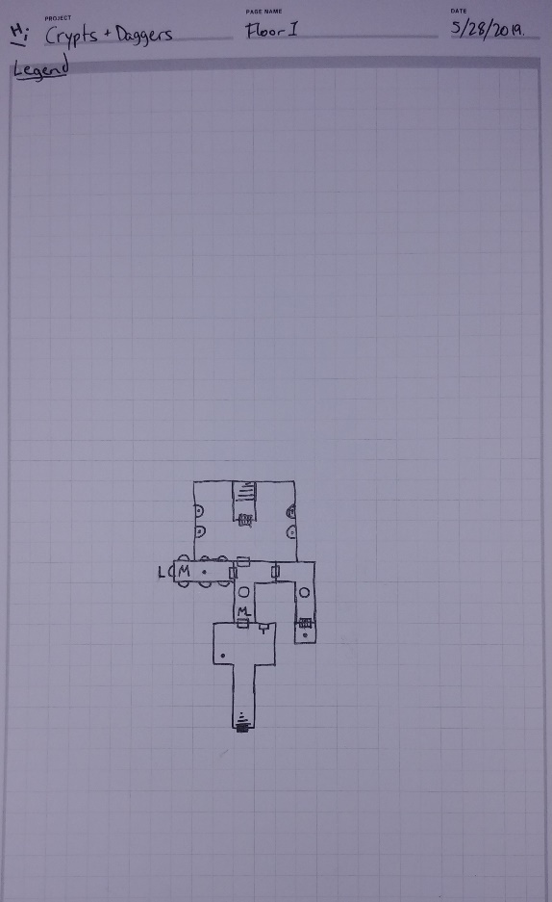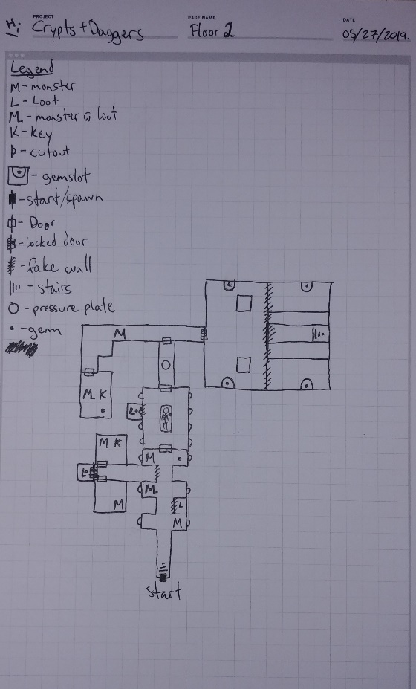

1. Story

The player started as a simple grave looter (a widely accepted trade in these parts, as the ancestors were thought to have lived is whorish splendor and wastefulness) but the entryway to this crypt crumbled when a large tombstone was knocked over. Faced with nowhere to go but down, the adventurer hopes to find enough power to make it to a way out, or make on of their own…

1. Technical

C&D is orthographic top-down, this means that there is no need for complicated physics systems as there will be no vertical mobility.

1. Timeline
   1. Design/Planning – (1 week)
   2. Pre-Production – (1 week)
   3. Production – (4 weeks)
   4. Post-Production – (indefinite)